Project Plan
Designing a Secure Cloud-Integrated Network Architecture for a Small-Medium Enterprise (SME)
Unit: COIT13236
Date: 20 July 2025
Project Mentor: Sunil Seneviratne
Group Members:
- Kenneth Christian (S0283279)
- Fan Zhang (12035271)
- Carl Khyncer Bhryn, YURONG (12224629)
- Chris Bruhn (12195842)

Table of Contents
1 Overview 2
2 Tasks 3
3 Group Member Roles (NICE Framework) 5
4 Responsibilities 5
5 Resource Requirements 7
5.1 In-Kind Resources 7
5.2 Cash Resources 8
5.3 Personnel Resources 8
6 Project Risks and Mitigation 8
7 Project Schedule Overview 10
8 Ethical and Professional Issues 12
8.1 Privacy and Data Protection 12
8.2 Security Misconfiguration or Oversights 12
8.3 Vendor Lock-In and Dependence on Proprietary Cloud Services 12
8.4 Intellectual Property and Project Ownership 13
8.5 Professional Conduct and Collaboration 13
8.6 Staff Training and Post-Deployment Support 13
8.7 Informed Consent and Transparency 14
8.8 Inclusive and Equitable Access 14
8.9 Environmental and Social Responsibility 14
8.10 Payment Gateway Security and Financial Data Handling 14

Overview
Designing a Secure Cloud-Integrated Network Architecture for a Small-Medium Enterprise (SME). This project focuses on building a practical, secure, and scalable network infrastructure that integrates on-premises networking equipment with cloud services, tailored specifically for a small First Aid Training Centre. The aim is to support essential IT operations — including staff communication, client and student access, cloud collaboration — using affordable, real-world technologies.
Small education providers with limited IT budgets often struggle to implement a secure, reliable, and scalable network infrastructure that can support academic operations. The organisation may lack in-house IT expertise, leading to Unsecured Wi-Fi access, poorly segmented networks and limited or unreliable cloud integration. Without a properly designed hybrid network, they face issues like downtime, security vulnerabilities, and inefficient collaboration.
We will design a secure hybrid network architecture using Cisco routers, switches and Ubiquiti Wi-Fi access points. Segment the network using VLANs to separate students, staff and guests. Implement security controls including firewalls and ACLs to protect the system from internal and external threats. Integrate cloud services for file sharing, email, and collaboration. At the end, we will test and validate the solution to ensure it meets the business needs of a small education. To keep the project focused and achievable within time and resource constraints, the prototype will be limited to a single-site implementation only, with no inter-campus connectivity. Will not include advanced automation, machine learning-based monitoring, or self-healing systems.
By implementing our proposed network solution, the client will benefit in several key areas. Improved security will be achieved through network segmentation using VLANs, which reduces internal risks by separating staff and students. Additional security measures such as firewalls and content filtering will help protect against external threats and unauthorised access. The solution also ensures reliable connectivity, providing staff and students with stable and secure access to both local infrastructure and cloud-based services. From a financial standpoint, the solution is designed for cost-effectiveness, utilising affordable hardware and cloud services that are ideal for small to medium-sized enterprises, avoiding the need for expensive enterprise-level systems. The network is also designed with scalability, making it easy to expand and support additional users and new facilities as the organisation grows. The client will benefit from a better overall experience, with secure, high-performance access to both learning and administrative resources.

Tasks
This table provides a detailed breakdown of the tasks involved in the network infrastructure project, outlining each task's description, the expected deliverables, and the tools or methods to be used for verification. It serves as a comprehensive guide for project execution, ensuring clarity on responsibilities and outcomes for each stage of the network development and implementation.
Task | Description | Deliverable(s)
Task 1: Project Requirement Analysis | Meet with the mentor (acting as the client) to clarify business needs, network scope, staff structure, and expectations. Identify technical and non-technical requirements. | Specification document and meeting notes
Task 2: Site Analysis and Logical Layout Planning | Define physical areas (classrooms, offices), user roles, and expected network demands. | Layout diagram, room mapping
Task 3: Wi-Fi Network Design | Design secure wireless coverage zones using Ubiquiti access points for staff, students, guests. | Wi-Fi SSID plan, access control policies, coverage diagram
Task 4: VLAN Design and IP Addressing Scheme | Allocate subnets and VLAN IDs to separate network traffic (e.g. Staff VLAN, Student VLAN, Guest VLAN). | VLAN table, IP address plan,
Task 5: Physical Network Design | Plan cable runs, switch placement, and core/router connectivity using Cisco equipment. | Network topology diagram, cabling layout plan
Task 6: Firewall and ACL Policy Development | Define firewall rules and router-based Access Control Lists (ACLs) to enforce security between VLANs. | Firewall rule set, ACL configuration table
Task 7: DNS Filtering and Web Access Control | Set up a DNS filtering system to block malicious or inappropriate sites on student and guest networks. | DNS filter configuration, blacklist/whitelist policy
Task 8: Network Configuration and Setup | Configure Cisco switches, routers, VLANs, routing, DHCP, and NAT on lab equipment. | Running configuration files, command logs, interface documentation
Task 9: Wireless Network Setup | Deploy and configure Ubiquiti Wi-Fi APs with WPA2/WPA3 encryption, SSID segmentation, and bandwidth limitations. | AP configuration snapshots, SSID test report
Task 10: Cloud Services Integration Planning | Plan how Microsoft 365 will be used by staff and tutors for email, file sharing, and collaboration. | Cloud integration strategy document, user role access matrix
Task 11: Cloud Service User Setup | Create cloud accounts for staff and tutors, set folder access rights, and test file sharing and calendar syncing. | User provisioning report, cloud functionality demo
Task 12: Security Testing and Validation | Test network segmentation, ACL enforcement, DNS filtering, and firewall operation using multiple devices. | Security test report, screenshots of blocked traffic/access attempts.  Tools like Wireshark or ping tests will be used to verify ACLs, VLAN isolation.
Task 13: Performance Testing | Measure bandwidth, latency, and wireless signal strength across the facility. Identify bottlenecks or misconfigurations. | Performance test results, troubleshooting log
Task 14: Risk Assessment and Mitigation | Identify risks such as configuration errors, device failure, or security lapses. Propose mitigation strategies. | Risk register, mitigation plan
Task 15: Documentation of Network Design | Create formal documentation including topology diagrams, IP plans, configuration guides, and user access policies. | Network design report, handover documentation
Task 16: Prototype Demonstration and Walkthrough | Demonstrate the live network setup, showing staff access, student access, cloud connectivity, and network controls. | Presentation
Task 17: Final Report and GitHub Submission | Compile all project components and submit a final report and GitHub repository with documentation and configuration files. | Final report, GitHub submission

Group Member Roles (NICE Framework)
Student | NICE Role Title | Role Description | Justification
Kenneth Christian | Network Operations Specialist (OM-NET-001) | Responsible for designing and configuring the physical and logical network infrastructure, including VLANs, IP addressing, and switch/router configuration. | This role is essential to ensure proper design, deployment, and troubleshooting of the on-premises infrastructure using Cisco and Ubiquiti hardware.
Fan Zhang | System Administrator (OM-ADM-001) | Manages the configuration of DHCP, DNS filtering, Wi-Fi access points, and device security policies such as SNMP, SSH, and WPA3. | This role is crucial for securing and maintaining operational services across all networked systems and ensuring proper segmentation and access controls.
Chris Bruhn | Cloud Security Analyst | Leads the integration and security configuration of cloud services such as Microsoft 365, including access controls, user provisioning, and file sharing. | Given the hybrid network nature of the project, this role is needed to manage secure cloud access and apply relevant security policies.
Carl Khyncer Bhryn, YURONG | Cyber Defense Analyst (PR-CDA-001) | Handles firewall and ACL implementation, risk assessment, vulnerability testing, and creation of the security checklist and mitigation plan. | This role is critical for identifying threats, ensuring VLAN isolation, and validating implemented security measures that are effective.

Responsibilities
This table outlines the assigned roles for each group member, aligning them with relevant NICE (National Initiative for Cybersecurity Education) framework titles. For each student, the table details their specific responsibilities within the project and provides a justification for the importance of their role in achieving the project's objectives.
Task | Technical Lead | Assistants
Requirement Gathering & Client Consultation | Carl Khyncer Bhryn, YURONG  Chris Bruhn | Kenneth Christian  Fan Zhang
Site Layout and Zone Mapping | Carl Khyncer Bhryn, YURONG  Chris Bruhn | Kenneth Christian  Fan Zhang
Wi-Fi Network Design | Kenneth Christian  Fan Zhang | Carl Khyncer Bhryn, YURONG  Chris Bruhn
VLAN and Subnet Design | Carl Khyncer Bhryn, YURONG  Chris Bruhn | Kenneth Christian  Fan Zhang
Physical Network Topology | Kenneth Christian  Fan Zhang | Carl Khyncer Bhryn, YURONG  Chris Bruhn
Router Configuration & WAN Setup | Kenneth Christian  Fan Zhang | Carl Khyncer Bhryn, YURONG  Chris Bruhn
Firewall and ACL Design and Setup | Carl Khyncer Bhryn, YURONG  Chris Bruhn | Kenneth Christian  Fan Zhang
DHCP and DNS Setup | Kenneth Christian  Fan Zhang | Carl Khyncer Bhryn, YURONG  Chris Bruh
Cloud Service Integration | Carl Khyncer Bhryn, YURONG  Chris Bruh | Kenneth Christian  Fan Zhang
VPN Implementation (Optional) | Kenneth Christian  Fan Zhang | Carl Khyncer Bhryn, YURONG  Chris Bruh
Security Hardening | Carl Khyncer Bhryn, YURONG  Chris Bruh | Kenneth Christian  Fan Zhang
Network Configuration Deployment | Kenneth Christian  Fan Zhang | Carl Khyncer Bhryn, YURONG  Chris Bruh
Functionality Testing | Kenneth Christian  Fan Zhang | Carl Khyncer Bhryn, YURONG  Chris Bruh
Performance Testing | Carl Khyncer Bhryn, YURONG  Chris Bruh | Kenneth Christian  Fan Zhang
Risk Assessment and Mitigation | Carl Khyncer Bhryn, YURONG  Chris Bruh | Kenneth Christian  Fan Zhang
Documentation and User Guide | Kenneth Christian  Fan Zhang | Carl Khyncer Bhryn, YURONG  Chris Bruh
Prototype Demonstration | Kenneth Christian  Fan Zhang  Carl Khyncer Bhryn, YURONG  Chris Bruh
Final Submission and GitHub Repository | Kenneth Christian  Fan Zhang  Carl Khyncer Bhryn, YURONG  Chris Bruh

Resource Requirements
This section details the various resources required for the project, categorizing them into in-kind, cash, and personnel resources. It provides justification for each resource's necessity, its source, and associated costs or licensing information, offering a comprehensive overview of the project's resource allocation.

In-Kind Resources
Resource | Justification | Source | Cost/License
Cisco Routers & Switches (CQU Lab) | Used to configure the on-prem network, VLANs, and routing as part of physical network deployment and testing. | Provided by CQU Townsville | No Cost (Note: Normal Cost $1754.54 for Cisco Router)  No Cost (Note: Normal Cost $1139,00 for Cisco Switch)
Ubiquiti Wi-Fi Access Points | Required for setting up segmented wireless networks for staff, students, and guests. | Provided by CQU Townsville | No Cost (Normal Cost $797.00 Access Points box 3x)
Microsoft 365 (Student License) | Used to simulate cloud integration for email, file sharing, and collaboration for staff. | Available via student license | No cost
Azure | Used to simulate cloud infrastructure such as virtual machines, storage, and VPN for hybrid integration tasks | Online | Partially Covered by Azure for Students subscription
DNS Filtering | Used to implement content filtering on student and guest networks. | Open source | No cost
Wireshark | Used for testing and validating VLAN segmentation and security controls. | Open source | No cost
OpenSSL | Required to implement and test encryption protocols and secure communications in network and application layers. | Open source | No cost
Ubuntu Linux | OS platform hosting firewall, VPN server, and cloud service integration testing. | Open source | No cost

Cash Resources
Resource | Justification | Source | Cost
Ethernet cables, patch panels, connectors | Required physically connecting routers, switches, and end devices in lab setup. | Officeworks | $50
Console Cable | For configuring Cisco routers/switches. | Officeworks | $20
Azure | Used to simulate cloud infrastructure such as virtual machines, storage, and VPN for hybrid integration tasks | Microsoft | $250  AS Partially Covered by Azure for Students subscription

Personnel Resources
Role | Team Member | Estimated Hours | Hourly Rate | Total Cost
Network Operations Specialist | Kenneth Christian | 40 hours | $40/hour | $1,600
System Administrator | Fan Zhang | 35 hours | $40/hour | $1,400
Cloud Security Analyst | Chris Bruhn | 30 hours | $40/hour | $1,200
Cybersecurity Analyst | Carl Khyncer Bhryn, YURONG | 35 hours | $40/hour | $1,400

Project Risks and Mitigation
This table identifies potential project risks and outlines corresponding mitigation strategies. It covers a range of challenges, from common project management issues like group member sickness and resource limitations to various cybersecurity threats such as credential-based attacks, malware, and denial of service. For each risk, a clear plan of action is provided to minimize its impact on the project's success.
Risk ID | Risk | Mitigation
R001 | Group member is sick for multiple weeks | Have backup assignees for all critical roles. Reassign responsibilities temporarily and extend internal deadlines if needed.
R002 | Delays in accessing CQU lab equipment | Book lab slots well in advance; prepare alternate work on documentation or cloud tasks; simulate configs in Packet Tracer temporarily.
R003 | Cloud credits run out before project ends | Monitor usage weekly; optimize VM uptime; switch to free-tier services or open-source alternatives (e.g. self-hosted on CQU VMs).
R004 | Network hardware failure during testing | Have a spare device plan from CQU inventory; switch to alternate hardware (if compatible)
R005 | Scope creep due to overly ambitious design | Stick to agreed deliverables; schedule weekly reviews to realign; document all proposed changes and defer non-essential features
R006 | Network Failures during Post Go - Live | Designated Team Members to investigate/analysis and advise fellow team members and respected site member’s issue. Appropriate steps taken to solve.
R007 | Cyber Attack (Credential Based) | Adequate measures design, created and tested during development (i.e. Risk Based Authentication). Processor and Procedures along with response plan created, updated post go-live. Patching and updates as required. Require backups of data Staff training raising awareness. Penetration Testing to find vulnerabilities and areas of improvement
R008 | Cyber Attack (Malware) | During development and testing, implementation of Antivirus, Firewall, strong password, MFA and credential settings. Documentation process and procedures, updated post go-live and backs up of data. Patching and updates, penetration testing and checks for vulnerabilities. Staff Training and awareness
R009 | Cyber Attack (Network Based) | Post go-live updates and patching, Penetration testing which is documented relation and maintained best practices. Require back up of data and response plan/s are in place and maintained
R010 | Cyber Attack (Web Application | Ensure coding practices are maintained and adequate security tools are in place. Ensure updates and patching are timely, suitable and documented. Testing post go-live.
R011 | Cyber Attack (Insider & Physical) | Maintain physical security and measures to prevent access to buildings and hardware. Processors, procedures created and maintained. Adequate registers of access and I.T. assets/devices. Staff Training and awareness
R012 | Cyber Attack (Denial of Service “DoS” | Ensure Adequate Security Measures created and maintained various layers of network security.
R013 | Cyber Attack (Advance & Persistent) | Zero Trust Architecture developed and maintained, User awareness and monitoring, Penetration and detection, security patching and updates in timely manner, data loss prevention and encryption, response plans and readiness along suitable risk management. Documentation of processors and procedures.
R014 | Group collaboration issues (e.g. miscommunication, uneven contribution, missed deadlines) | Schedule weekly progress meetings using Microsoft Teams. Use shared documentation and version control to maintain transparency. Set internal deadlines ahead of assessment due dates.
R015 | Inadequate post-project support or training for staff | Deliver a live walkthrough and record training sessions for future reference. Appoint a designated contact for post-deployment queries.
R016 | Mishandling of financial data through insecure payment integration | Use only third-party PCI-compliant payment processors. Avoid storing any financial data. Enforce HTTPS, tokenised links, and train staff on secure practices.

Project Schedule Overview
The following schedule outlines the estimated timeline and dependencies for completing each task in our network infrastructure project. The project is planned over a 9-week period, allowing time for technical work, testing, documentation, and review milestones. Each task includes its expected duration and dependencies with other tasks. Our team uses a Kanban board on GitHub to assign and track task completion.
Phase | Task | Dependencies
Planning Phase  Week 1-2 | Requirement Gathering & Client Consultation | None
Planning Phase  Week 1-2 | Site Layout | Requirement Gathering
Planning Phase  Week 1-2 | Zone Mapping | Site Layout
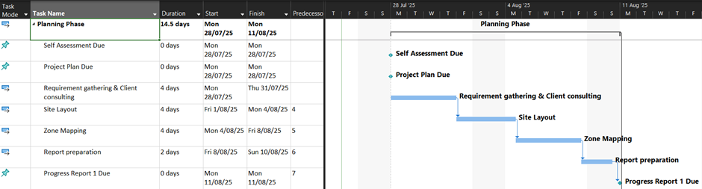
Design Phase  Week 3 | Wi-Fi Network Design
Design Phase  Week 3 | VLAN and Subnet Design | Wi-Fi Network Design
Design Phase  Week 3 | Physical Network Topology
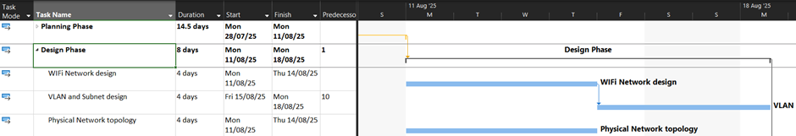
Development Phase  Week 4-5 | Router Configuration & WAN Setup
Development Phase  Week 4-5 | Firewall and ACL Setup | Router Configuration & WAN Setup
Development Phase  Week 4-5 | DHCP and DNS Setup | Router Configuration & WAN Setup
Development Phase  Week 4-5 | Cloud Service Integration
Development Phase  Week 4-5 | VPN Implementation | Cloud Service Integration
Development Phase  Week 4-5 | Network Configuration Deployment | Firewall and ACL Setup,  DHCP and DNS Setup,  VPN Implementation
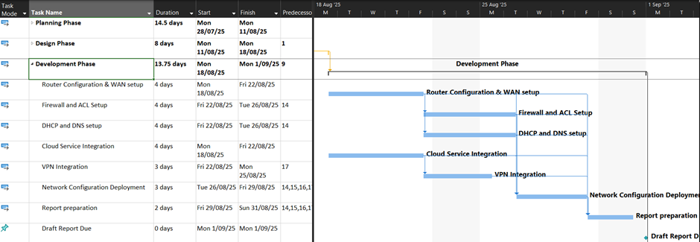
Deployment Phase  Week 6-7 | Security Hardening
Deployment Phase  Week 6-7 | Functionality Testing | Security Hardening
Deployment Phase  Week 6-7 | Performance Testing | Security Hardening
Deployment Phase  Week 6-7 | Risk Assessment and Mitigation | Security Hardening
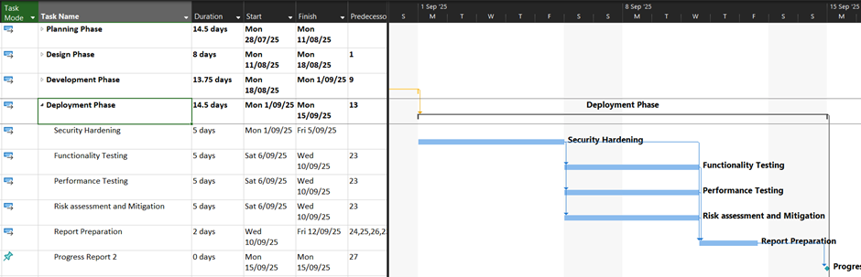
Delivery Phase  Week 8-9 | Documentation and User Guide
Delivery Phase  Week 8-9 | Defect Resolution
Delivery Phase  Week 8-9 | Prototype Demonstration
Delivery Phase  Week 8-9 | Final Submission and GitHub Repository
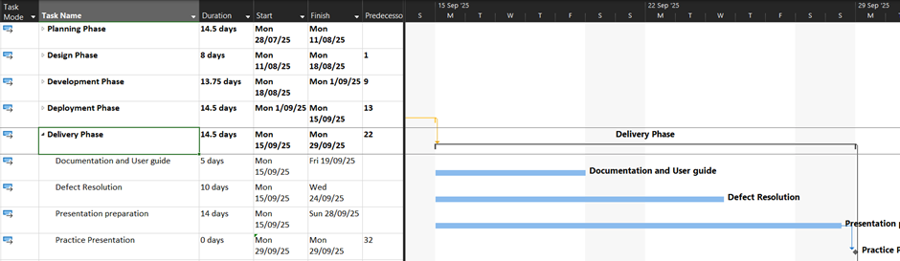
Finalisation Phase  Post delivery | Final preparation for assessment deliverables
Finalisation Phase  Post delivery | Ongoing system support
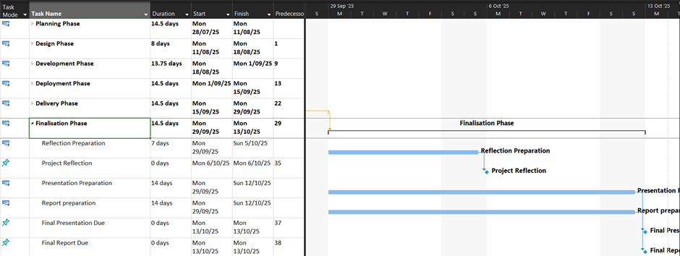

Ethical and Professional Issues

Privacy and Data Protection
When integrating cloud-based services, organisations may inadvertently store sensitive personal or business data in data centres located outside Australia. For a first aid training facility, this may include student registration details, finance and bank account details, attendance records, training certifications, and potentially health-related documentation. Such data, if hosted internationally, could violate the Australian Privacy Principles under the Privacy Act 1988 (Cth), which governs how personal information must be collected, stored, and disclosed. Data sovereignty is especially critical in education and healthcare contexts, where the misplacement or exposure of client information can have legal, ethical, and reputational consequences.
Mitigation: To ensure compliance with Australian privacy laws, the cloud service provider selected must offer Australian based data residency. Data should be encrypted in transit and at rest. The team must follow data minimisation principles, using only essential data required for training and certification purposes. Furthermore, all staff will be informed of their responsibilities around data access and sharing through clear privacy policies and induction training.

Security Misconfiguration or Oversights
One of the most common and dangerous cybersecurity threats arises from poor configuration of network and cloud systems. In this project, misconfigured firewalls, ACLs, wireless access policies, or settings could expose the SME to unauthorised access, data leaks, or privilege escalation attacks. For instance, if VLAN segmentation is incomplete of misapplied, students or guests may inadvertently gain access to staff resources. Similarly, open ports or incorrect NAT rules on routers may allow attackers to probe the internal network.
Mitigation: All system configurations will be developed based on industry-accepted standards. Each major step will undergo peer review by another group member, and changes tracked using version-controlled documentation. Additionally, the implemented configuration will be validated using penetration testing tools such as Nmap and Wireshark. Network-level testing will verify VLAN isolation.

Vendor Lock-In and Dependence on Proprietary Cloud Services
The SME’s adoption of specific cloud tools or configurations (e.g., Azure or AWS) introduces the risk of vendor lock-in, where reliance on proprietary systems limits the flexibility to migrate or integrate alternative tools in the future. This can result in increased operational costs or compatibility issues if the SME outgrows current needs or if the vendor changes pricing models. For small enterprises with limited IT budgets and technical resources, being tied to one provider without and exit strategy poses a long-term ethical concern regarding sustainability and autonomy.
Mitigation: Where possible, the network and cloud design will leverage open standards such as IMAP/STMP for email and SFTP for file sharing. All configuration documents will be thoroughly documented in human-readable formats (not locked behind proprietary interfaces). Additionally, the team will include an exit strategy guide as part of the final documentation, outlining how the SME could transition to another provider or on-premises system if desired. The client will also be briefed on the ongoing subscription costs and service limitations of cloud services to make informed decisions.

Intellectual Property and Project Ownership
The project involves creating configuration scripts, documentation, diagrams, and potentially custom scripts or automation tools. Additionally, the use of third-party open-source software introduces the need to comply with software licencing terms. Without clear definitions of ownership and rights, there is potential for disputes over who owns the deliverables – the project team, the SME, or CQUniversity.
Mitigation: All third-party software used in this project will be vetted to ensure it is used under permissive licences. Project documentation will explicitly state that the configuration templates and network designs are developed by the student team under educational fair use, and will be handed over to the SME (CQUniversity) with full rights to modify and use.

Professional Conduct and Collaboration
As a team, maintaining fairness, transparency, and professionalism is essential. Risks include unequal participation, interpersonal conflicts, missed deadlines, and poor communication – all of which can compromise the integrity and success of the project. These issues could damage client trust or lead to project failure.
Mitigation: The team will adhere to the ACS Code of Conduct, maintaining integrity and mutual respect throughout the project. Weekly meetings will be scheduled with progress tracked on Kanban board on GitHub. Individual contributions will be tracked via comments and meeting logs. Any disputes or major setbacks will be escalated to the project mentor.

Staff Training and Post-Deployment Support
The SME has no in-house IT staff and limited technical expertise. Even a secure and well-built network can become vulnerable if users do not understand how to use or maintain it. Risks include accidental misconfiguration, unauthorised access, or failure to update software, which could expose the business to downtime or breaches after the project ends.
Mitigation: As part of the final delivery, the team will conduct a live demonstration and training session for staff, which will be recorded and shared for future reference. A user-friendly admin guide will be developed, including screenshots, common troubleshooting steps, and vendor support links. The team will simulate a two-week post-deployment support window, during which they will respond to any questions from the SME. Backup strategies and contact escalation processes will also be documented in the final report.

Informed Consent and Transparency
The use of DNS filtering, firewall logging, and cloud-based collaboration tools introduces the possibility of passive data collection or monitoring of user behaviour. Users – especially students or guests – may not be aware that their network usage is being monitored or filtered, which raises concerns around transparency and consent.
Mitigation: The Wi-Fi system will display a Terms of Use policy upon first connection to the guest SSID, informing users of internet restrictions and basic logging. Internal staff will be briefed during onboarding on what activity is logged and for what purpose. The system will be configured to minimise unnecessary logging, storing only operational logs needed for troubleshooting or security events.

Inclusive and Equitable Access
All users, including those with disabilities or low digital literacy, must be able to access and benefit from the network and systems. Failing to account for accessibility could lead to digital exclusion, limiting learning outcomes or staff productivity.
Mitigation: The cloud tools chosen will include strong accessibility features such as screen reader support, speech-to-text, and high-contrast options. Training materials and documentations will use plain language and avoid excessive technical jargon. Accessibility testing will be conducted where applicable, and users will be encouraged to provide feedback on any usability barriers they encounter.

Environmental and Social Responsibility
Running multiple virtual machines or leaving lab equipment powered on unnecessarily can increase energy consumption, contributing to the project's environmental footprint. Additionally, over-reliance on new hardware without repurposing existing resources may generate e-waste.
Mitigation: The team will adopt green computing principles, shutting down VMs and hardware when not in use. Billing dashboards will be monitored weekly to optimise uptime and resource usage. Existing hardware will be evaluated for reuse, and preference will be given to energy-efficient options. Environmental responsibility will also be discussed during client training, promoting sustainable digital practices.

Payment Gateway Security and Financial Data Handling
If the SME integrates an online payment gateway for accepting payments, this introduces significant ethical and legal responsibilities. Handling credit card information involves compliance with financial data protection laws. Ethical concerns arise if transactions are routed through non-secure or uncompliant systems, stored improperly, or exposed to insider threats.
Mitigation: To ethically manage financial transactions, the team will recommend using third-party PCI-compliant payment processors that handle payment data externally. Secure HTTPS encryption will be enforced on all webpages related to transactions, and integrations will use tokenised payment links rather than collecting data in-house. A privacy and refund policy will be displayed during payment to ensure informed consent. Staff training will also include financial fraud awareness, and logs of payment related activity will be stored securely for auditing without retaining sensitive cardholder data.

